**Projected Range & Objectives**

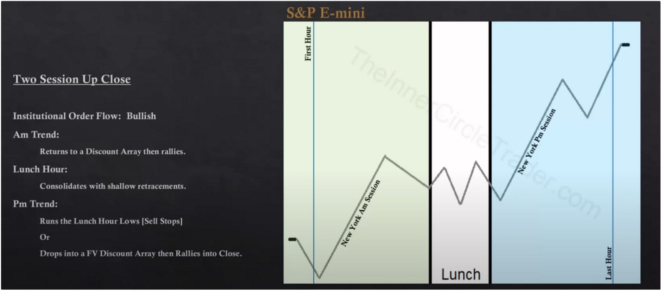

The daily range can go straight trough the lunch hour with very little consolidation whatsoever, depending on what the catalyst was that send prices higher it could be a very strong economic news release

Dont think we'll always get the consolidation in lunch hour, if we move higher fast theres a chance they work trough lunch

PM session would be ideal if its symetrical to the AM session

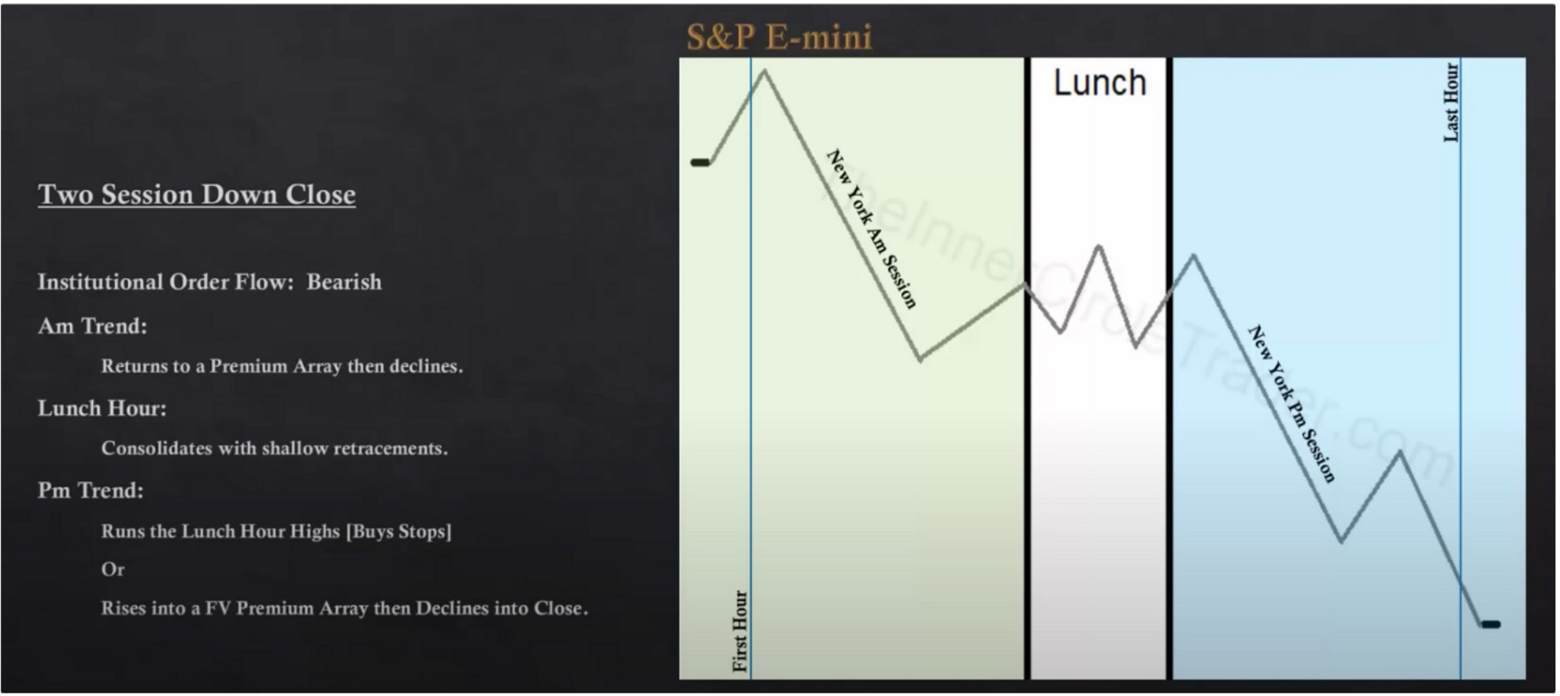

Focus on when the daily and 4h are bearish

If were in the middle of an intermediate term or long term price swing based on what we see on the HTF chart, then this is the classic scenario until we get to an opposing array on the 4h or daily or even weekly

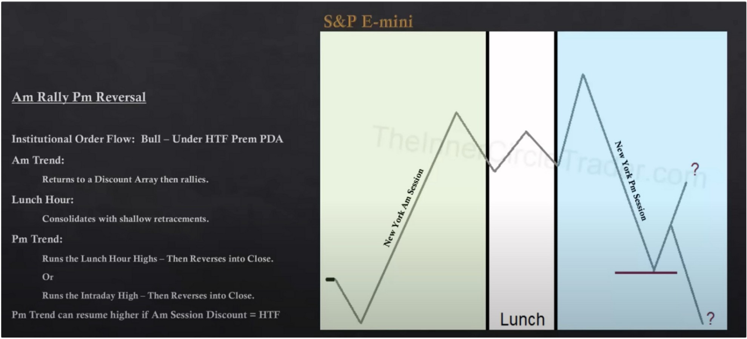

The PM trend could make a lower high when it reverses, dont always expect it to run out the AM high, so it can take out a short tern high and reverse

If it was a 15m or 1h discount array that caused the rally then we would expect the Pm session to go lower, but if it was a 4h or daily or weekly discount array then it could resume going higher. The filter is if it isnt a minmum 4h discount array then expect it to trade trough it and go lower

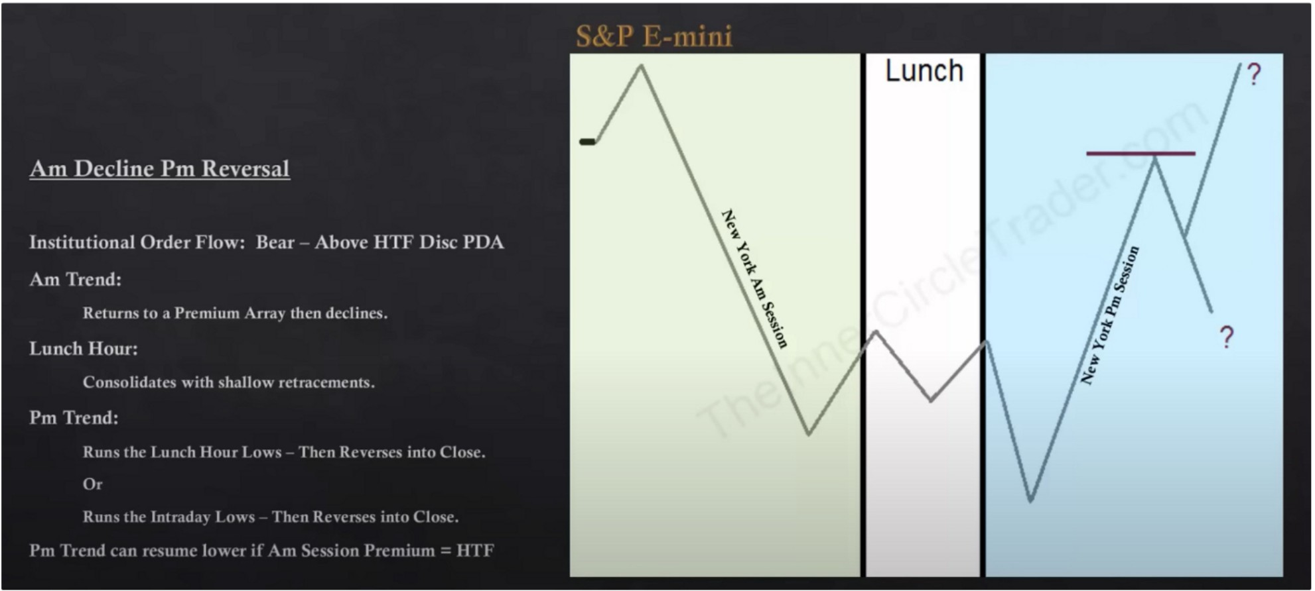

Consolidation am rally pm decline

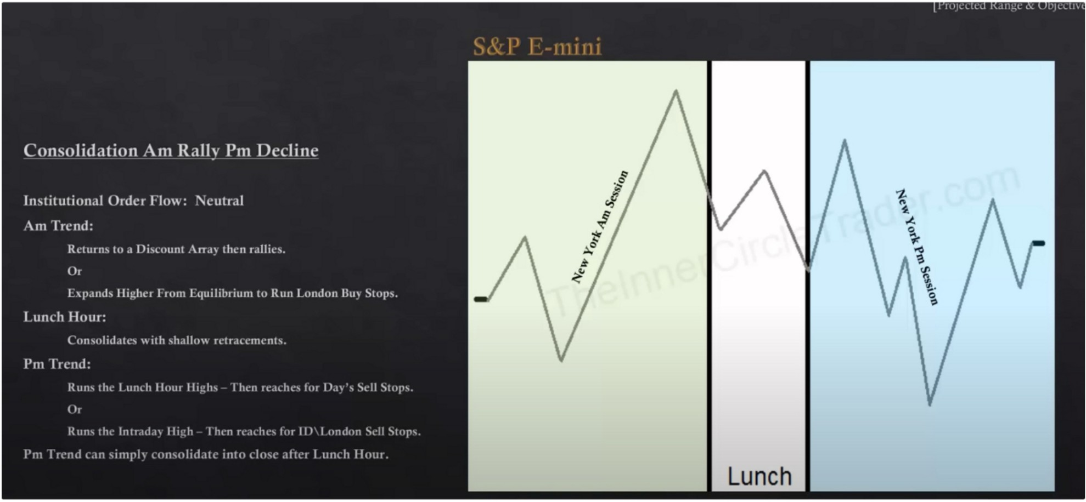

Happens especially when there no news and there isnt any market drivers

How do we know which one the PM trend will do? It depends on which is premium array, in other words if theres a HTF premium array that am session hit then its likely that the pm session wont go back up there because they have already defended that level and it may just only want to run the lunch hour highs.

If the AM session has not traded into a HTF premium array like an hourly or 4h then the PM can run the intraday high and reverse

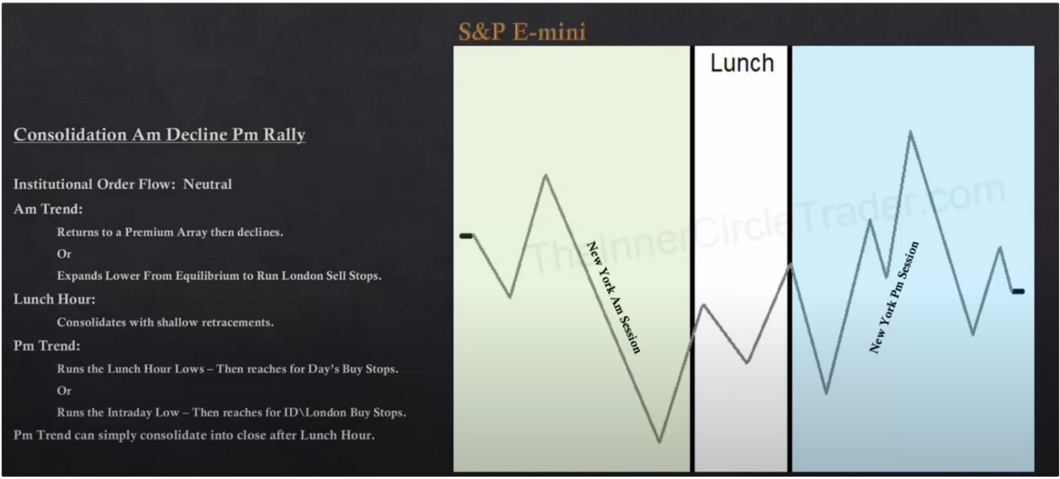

This is the classic scenario where you see that tug of war, this happens a lot in index trading which can be frustrating if you dont know the mechanics behind it

When the market and institutional orderflow suggest higher or lower price then DO NOT look for this scenario

This is not seek and destroy this is simply consolidation With NFP then we'll see seek and destroy in SP

This scenario will happen when theres a lack of trend and lack of news These templates make it very simple of what we want to see

The only time the lunch hour is different from consolidaiton is on trending days on the two session upclosed or downclosed templates, but its always going to be relative to what was the catalyst that drove price up

Indices seek stops, on a **HTF** they can trend but on an intraday basis its all about liquidity and where the stops are. Its a traders market so there fore theyre going to hunt stops pre dominantly

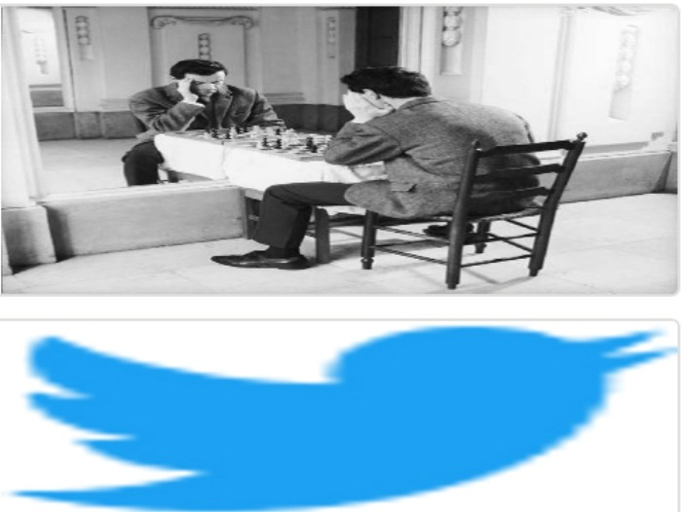Arjo I Twitter, lnstagram I Linktree

Linktree. Make your link do more.

1 https://t.co/HhmmTN1fUI

JavaScript is not available.

***"!I*** https://twitter.com/arjoio